VOYAGE VISTA-ILLUMINATING INSIGHTS FROM THE UBER EXPEDITIONARY ANALYSIS
Over View:
This analysis can help identify peak hours or days of high demand and optimize driveer availability during those times. Trips can be analyses based on geographic regions or specific cities to identify areas with higher demand.
Purpose:
Uber uses a mixture of internal and external data to estimate fares. Uber calculates fares automatically using street traffic data, GPS data and its own algorithms that make alternations based on the time of the journey.
Empathy Map:
This slide shows about quotient rised by people about Uber.
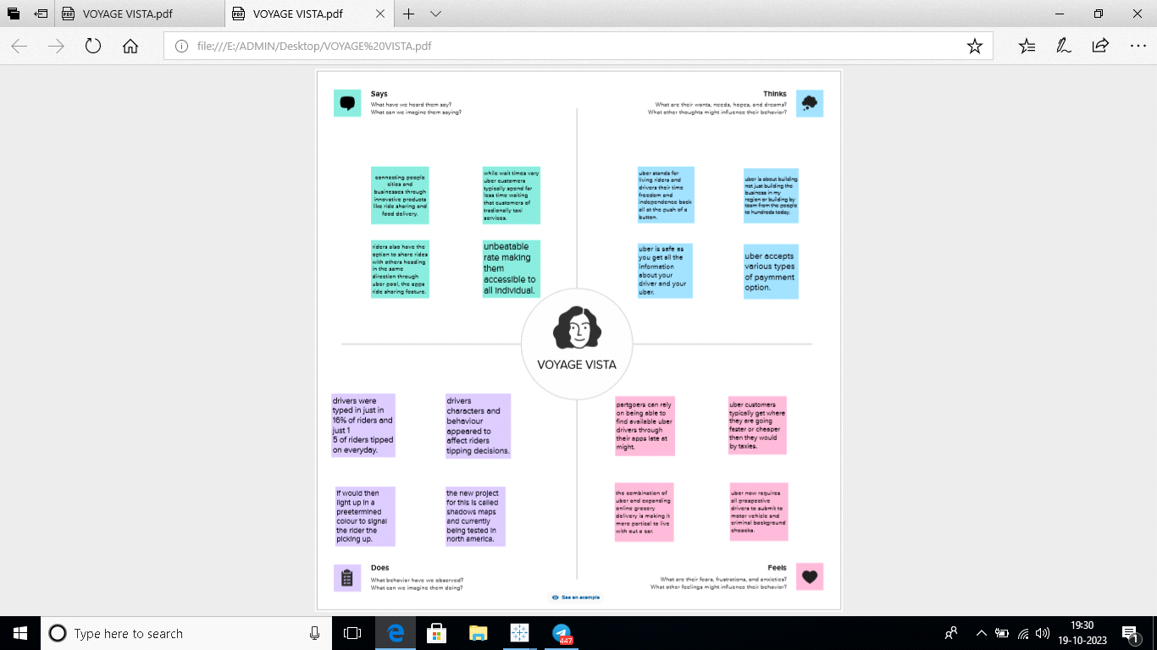
Ideation and Brainstorming Map:
Brainstorming tells about provides of Uber.

Result:
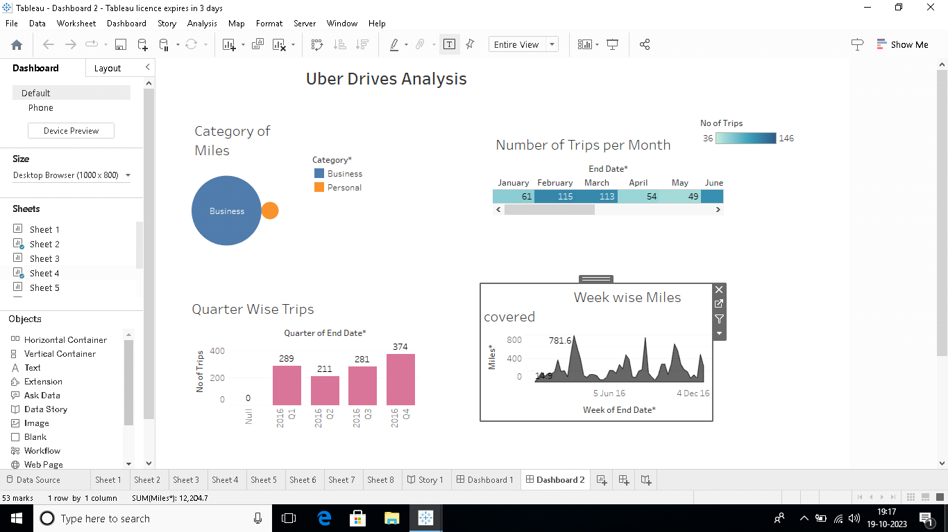
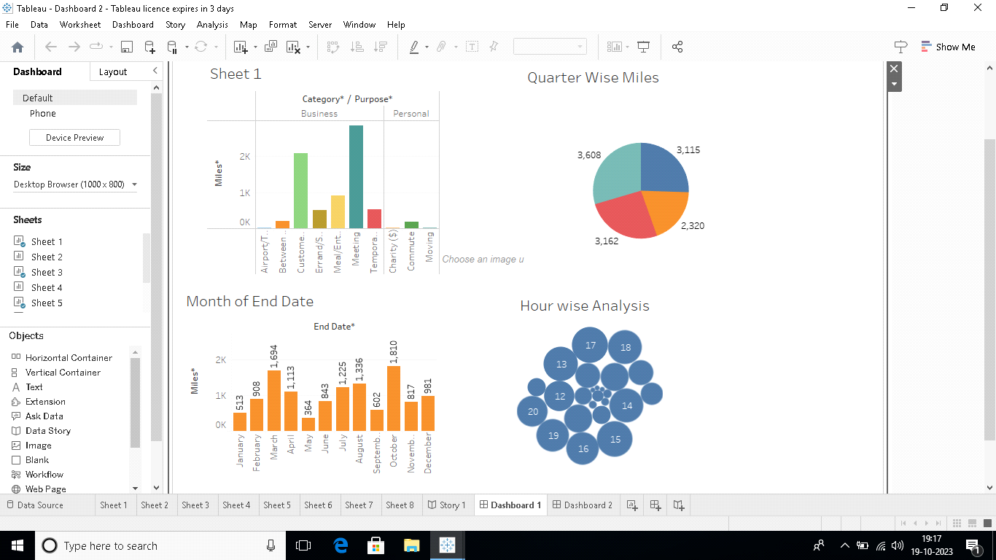
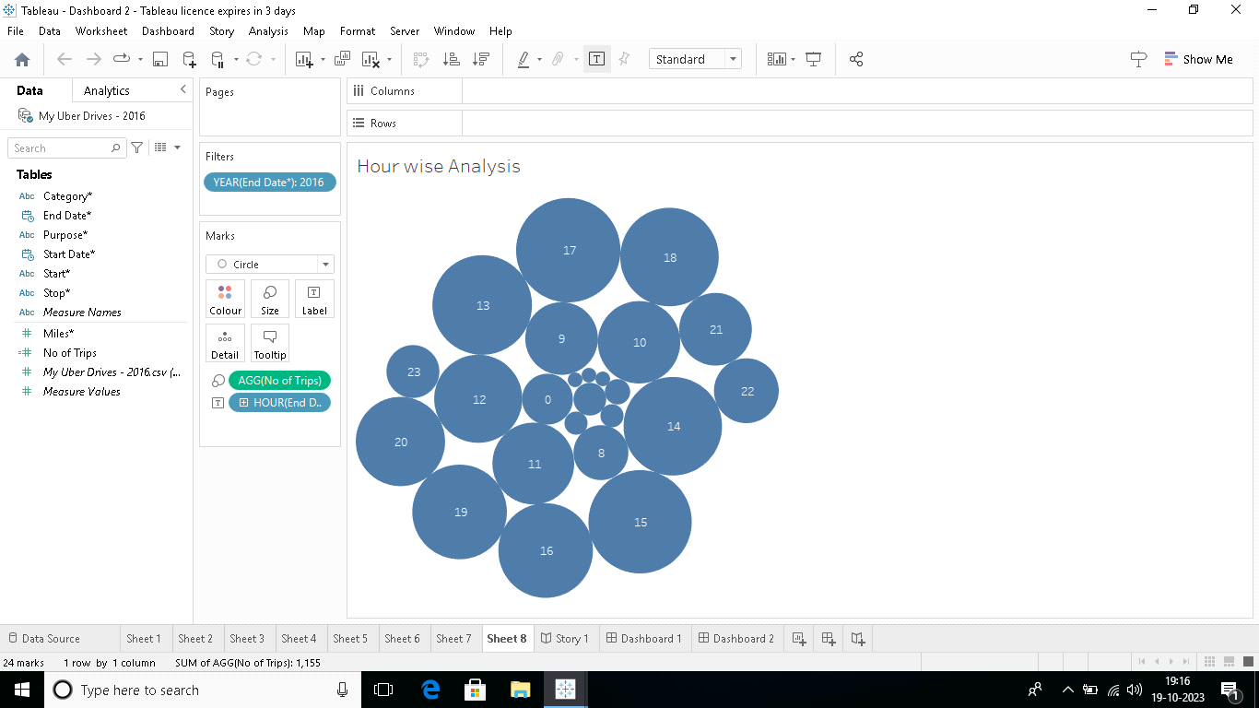
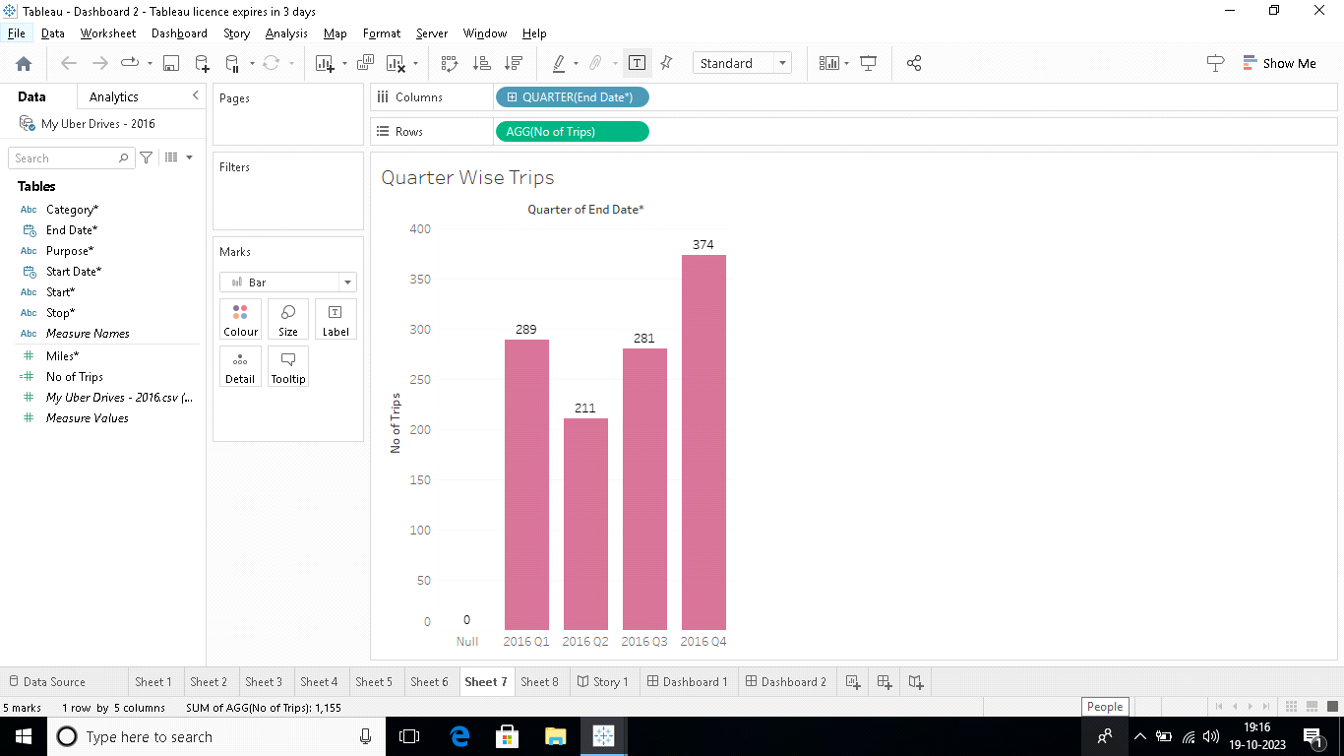
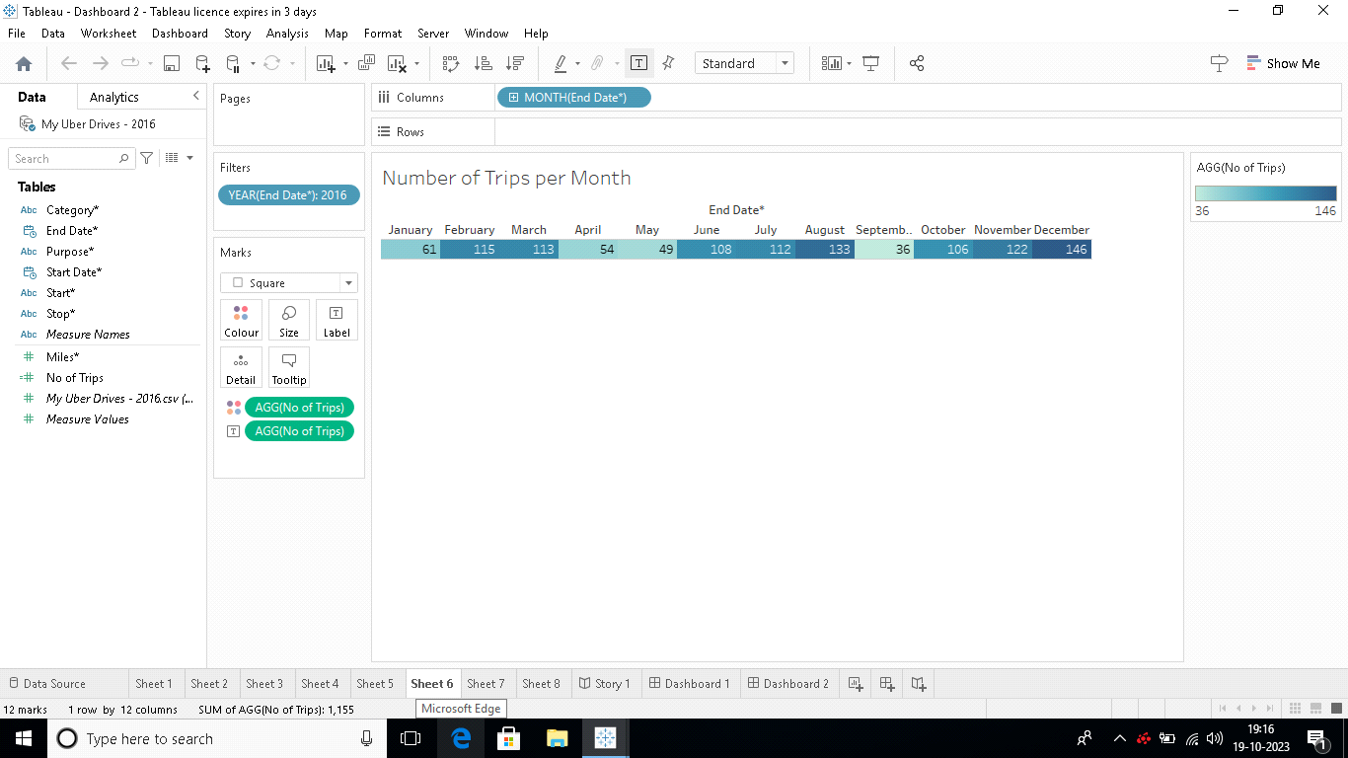
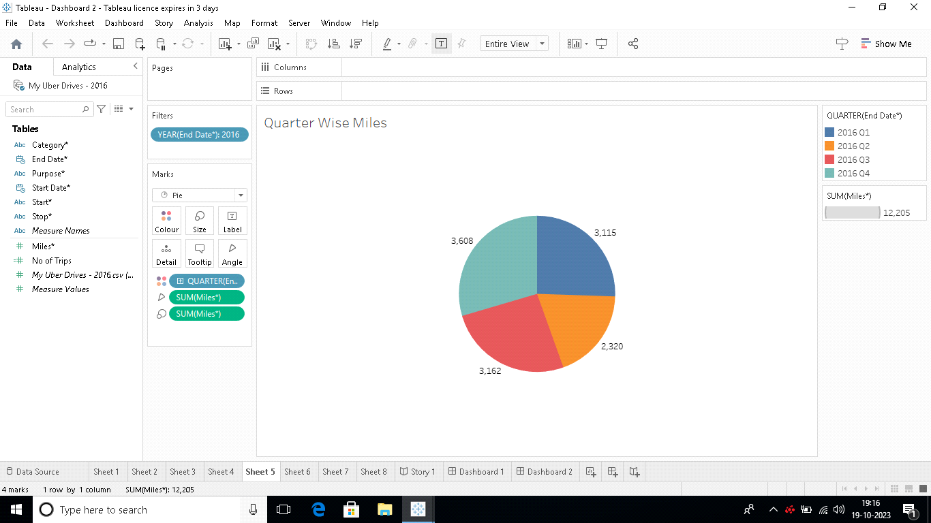
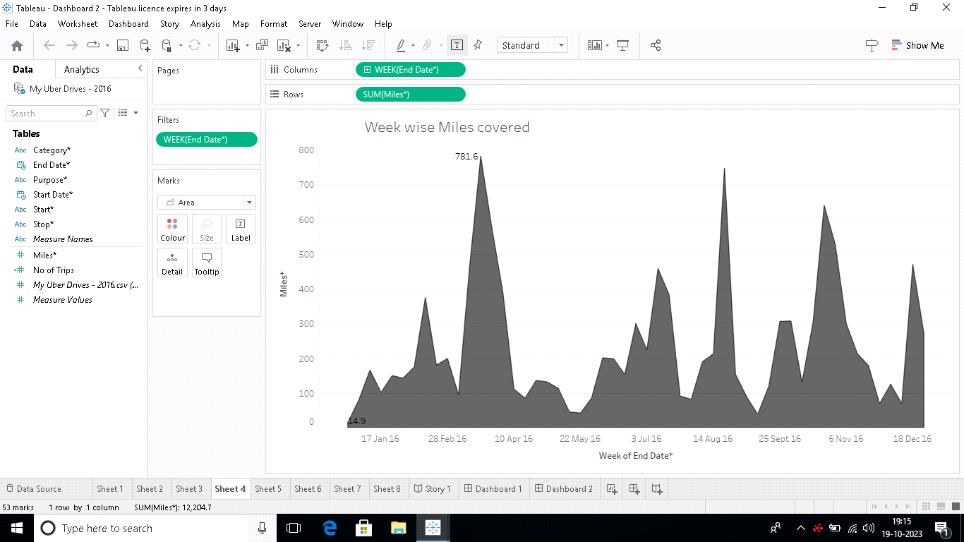
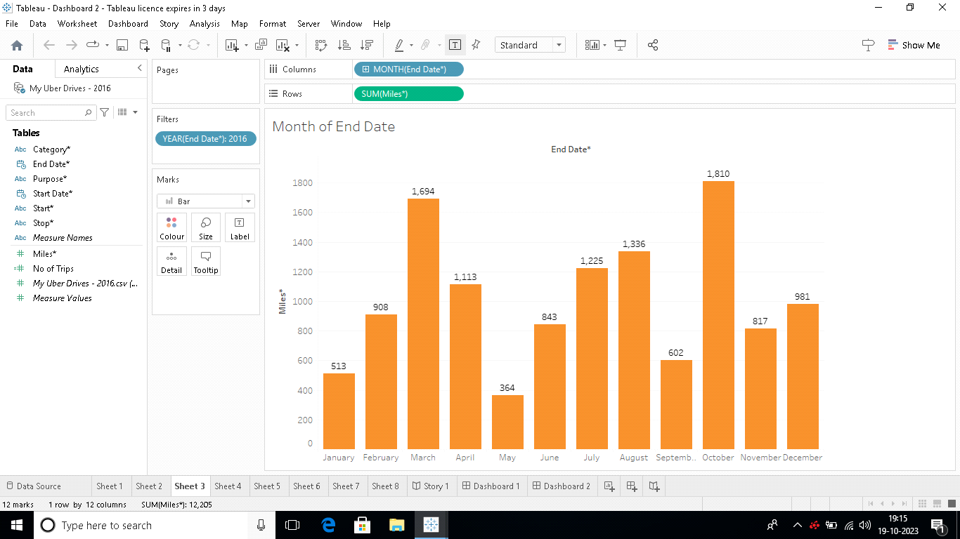

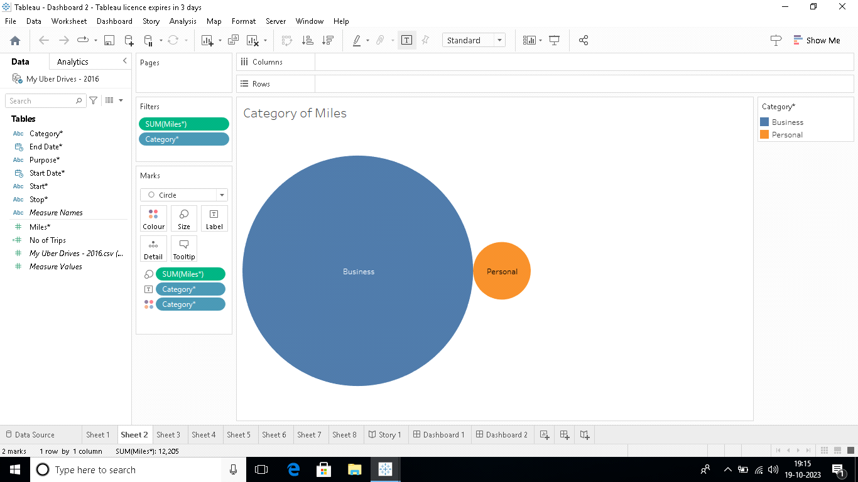
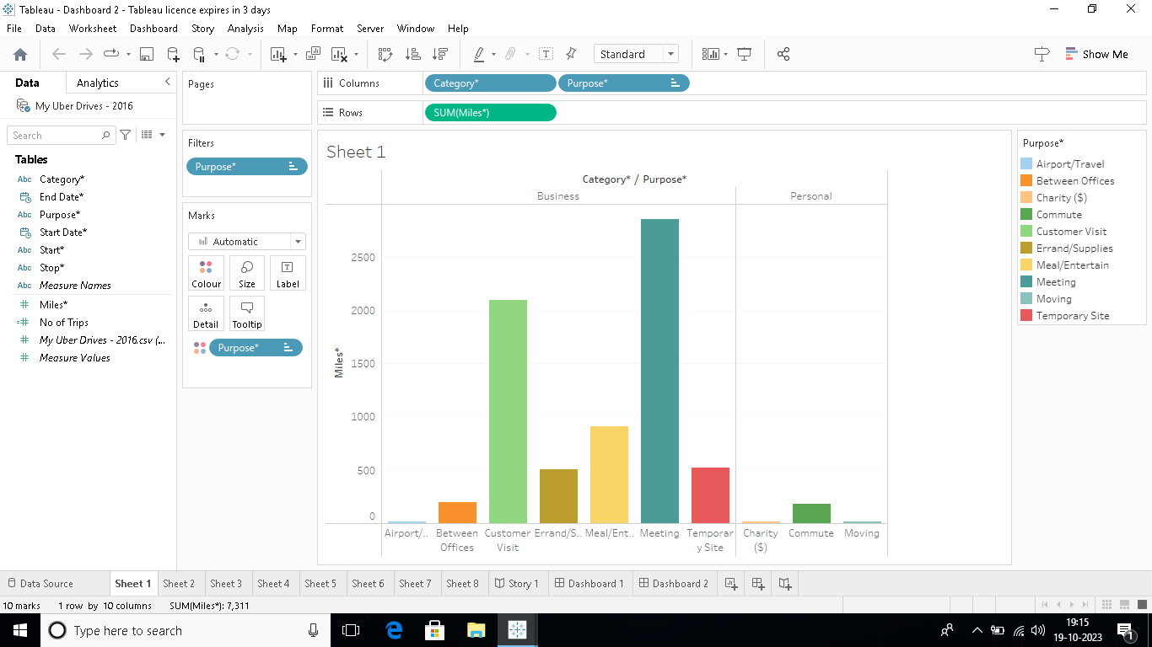

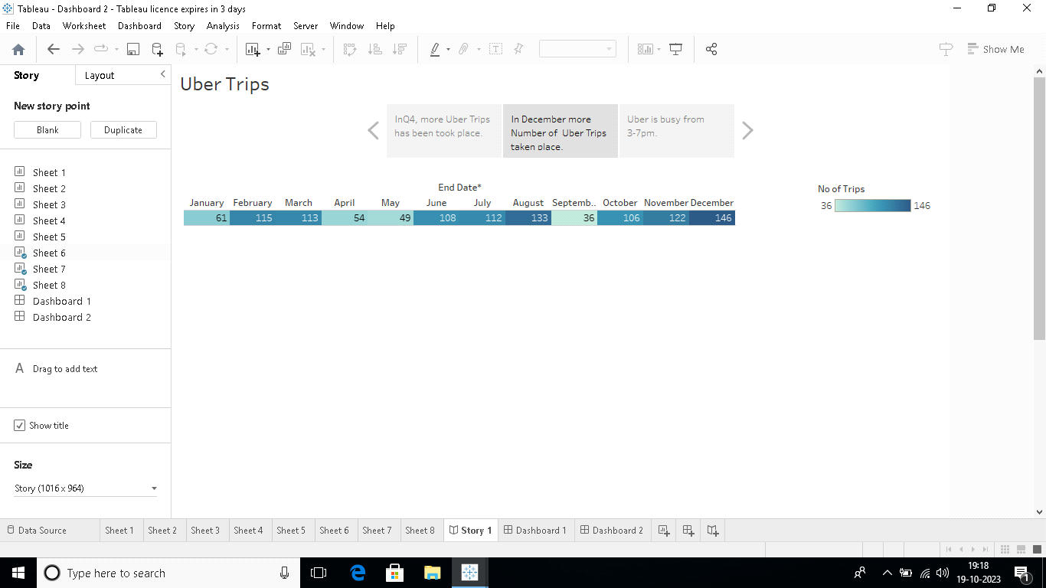

Advantages:
With Uber, you have security and peace of mind. Also, Uber is cheaper than any other type of rides. Taxi charges fare and the tip, but with Uber everything is included in the price you pay. Uber allow ride sharing also called carpool which makes it cheaper.
Disadvantages:
Uber's advantages include door-to-door convenience, safety, and reliable quality. Uber's disadvantages include its surge pricing and the negative effects of replacing steady jobs with gig work.
Application:
The leading technologies incorporated in the marketplace are Python, Node, Go, and Java. The trip execution engine is the backbone of Uber's marketplace platform. To ensure scalability and security, developers got creative with their development approach: Node.
Conclusion:
Tackling problems like poor transportation infrastructure in some cities, unsatisfactory customer experience, late cars, poor fulfilment, drivers denying to accept credit cards and more –Uber has “eaten the world” in less than 5 years and is a remarkable name to reckon when it comes to solving problems for people in transportation

